# **LAPORAN PRAKTIKUM INTERNET OF THINGS (IoT)**

# **Fakultas Vokasi, Universitas Brawijaya**

**Praktik Pembuatan Traffic Light ESP32**

*Christopher Aldrinovito Andriawan*

*Fakultas Vokasi, Universitas Brawijaya*

*Email:alexzvito123@student.ub.ac.id*

**1. Introduction**

Merangkai Lampu Lalu Lintas (Traffic Light), Terdiri dari 3 LED berwarna hijau, merah, dan kuning. Dan menyala secara bergantian.

**1.1 Latar belakang**

Mempersiapkan akun untuk pembelajaran dan pelaporan progress ke depan

**1.2 Tujuan eksperimen**

Membuat rangkaian dan code traffic light

**2. Methodology (Metodologi)**

**2.1 Tools & Materials (Alat dan Bahan)**

1. Wokwi
2. Github
3. Vscode

**2.2 Implementation Steps (Langkah Implementasi)**

1. Edit Rangkaian di Wokwi

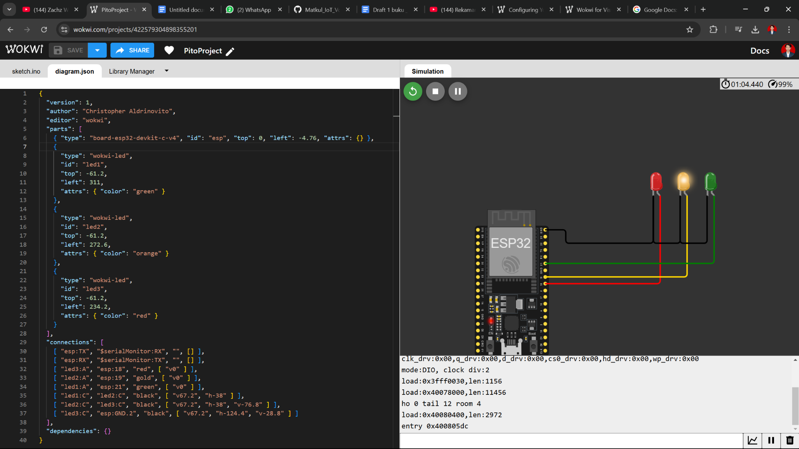

1. Copy *diagram.json* untuk di vscode

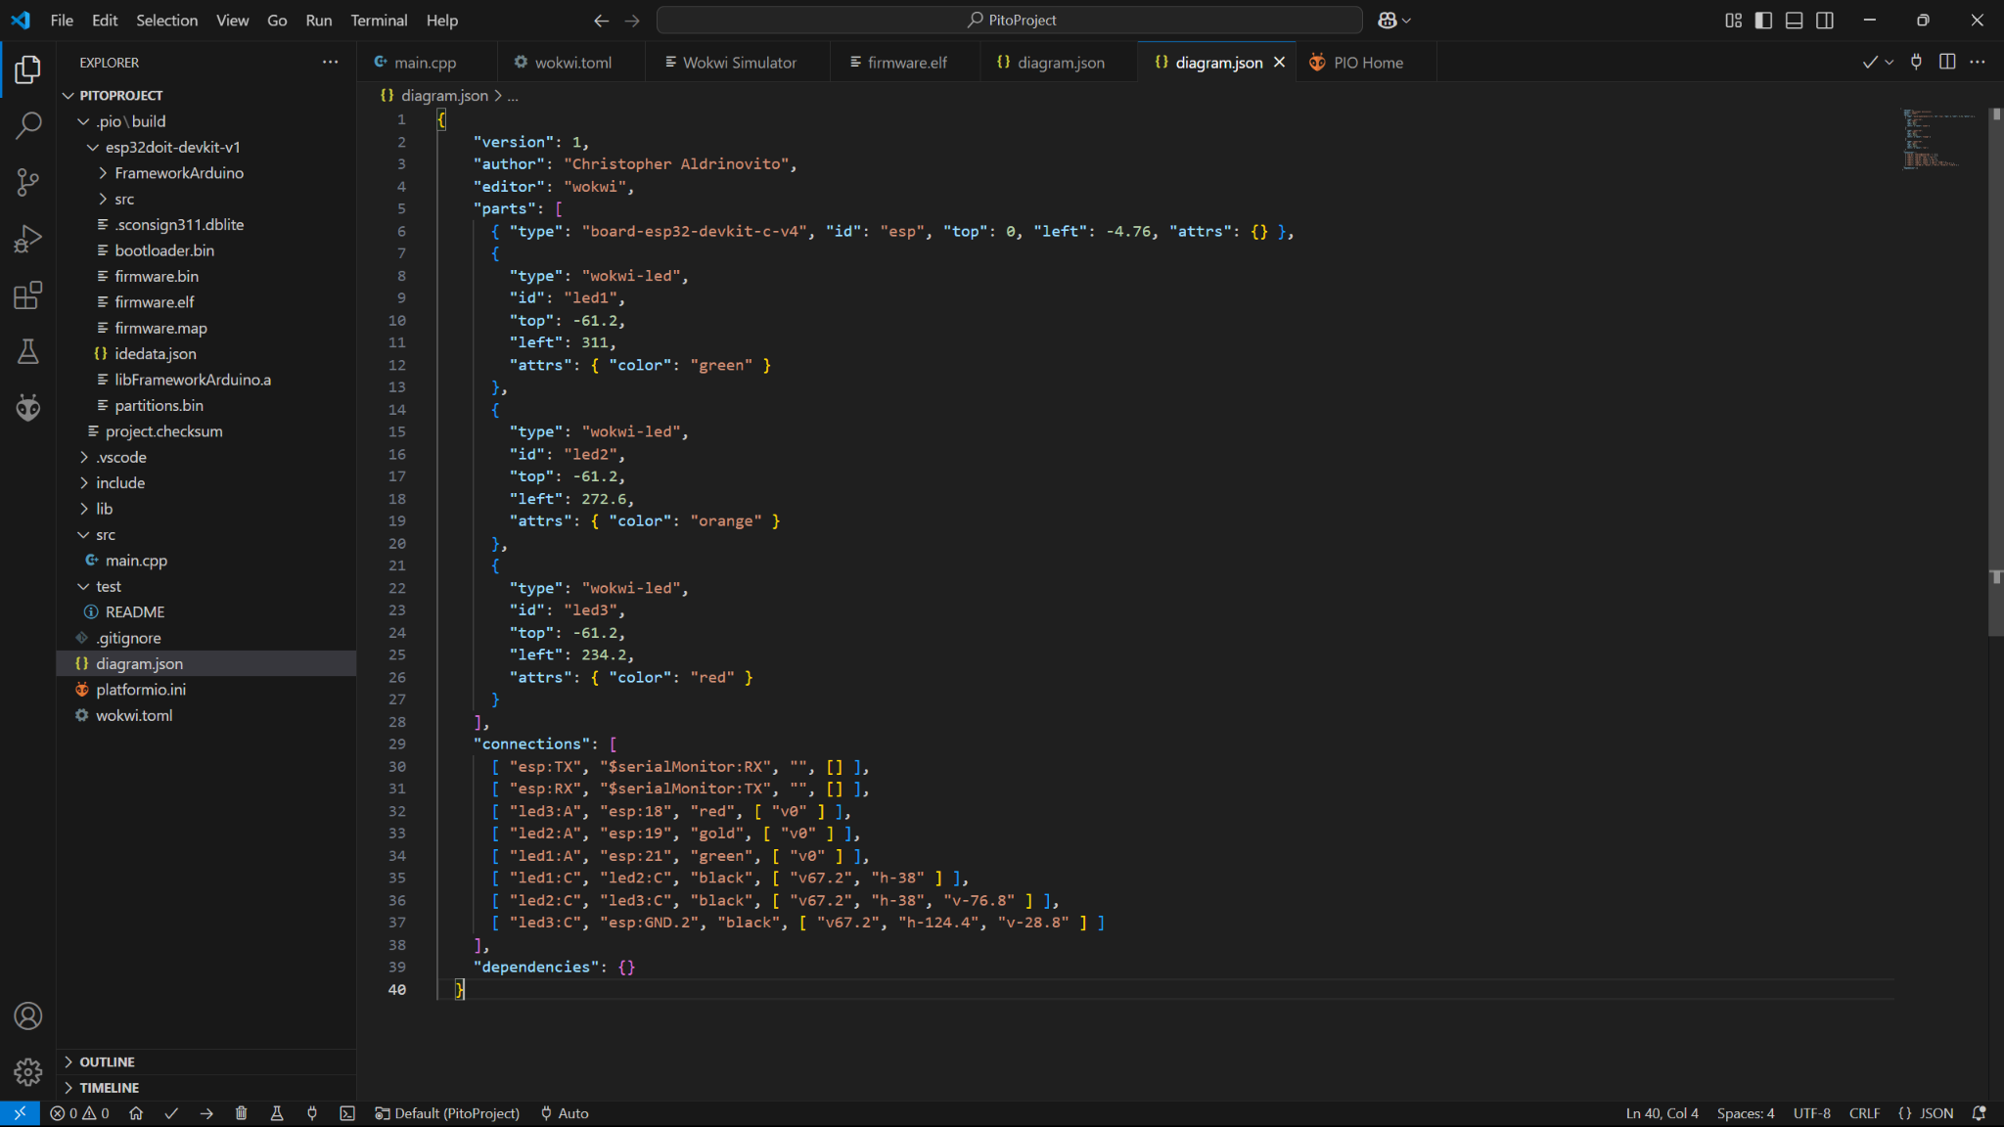

1. Buat Code untuk traffic light yang akan menyala sesuai dellay yang di atur

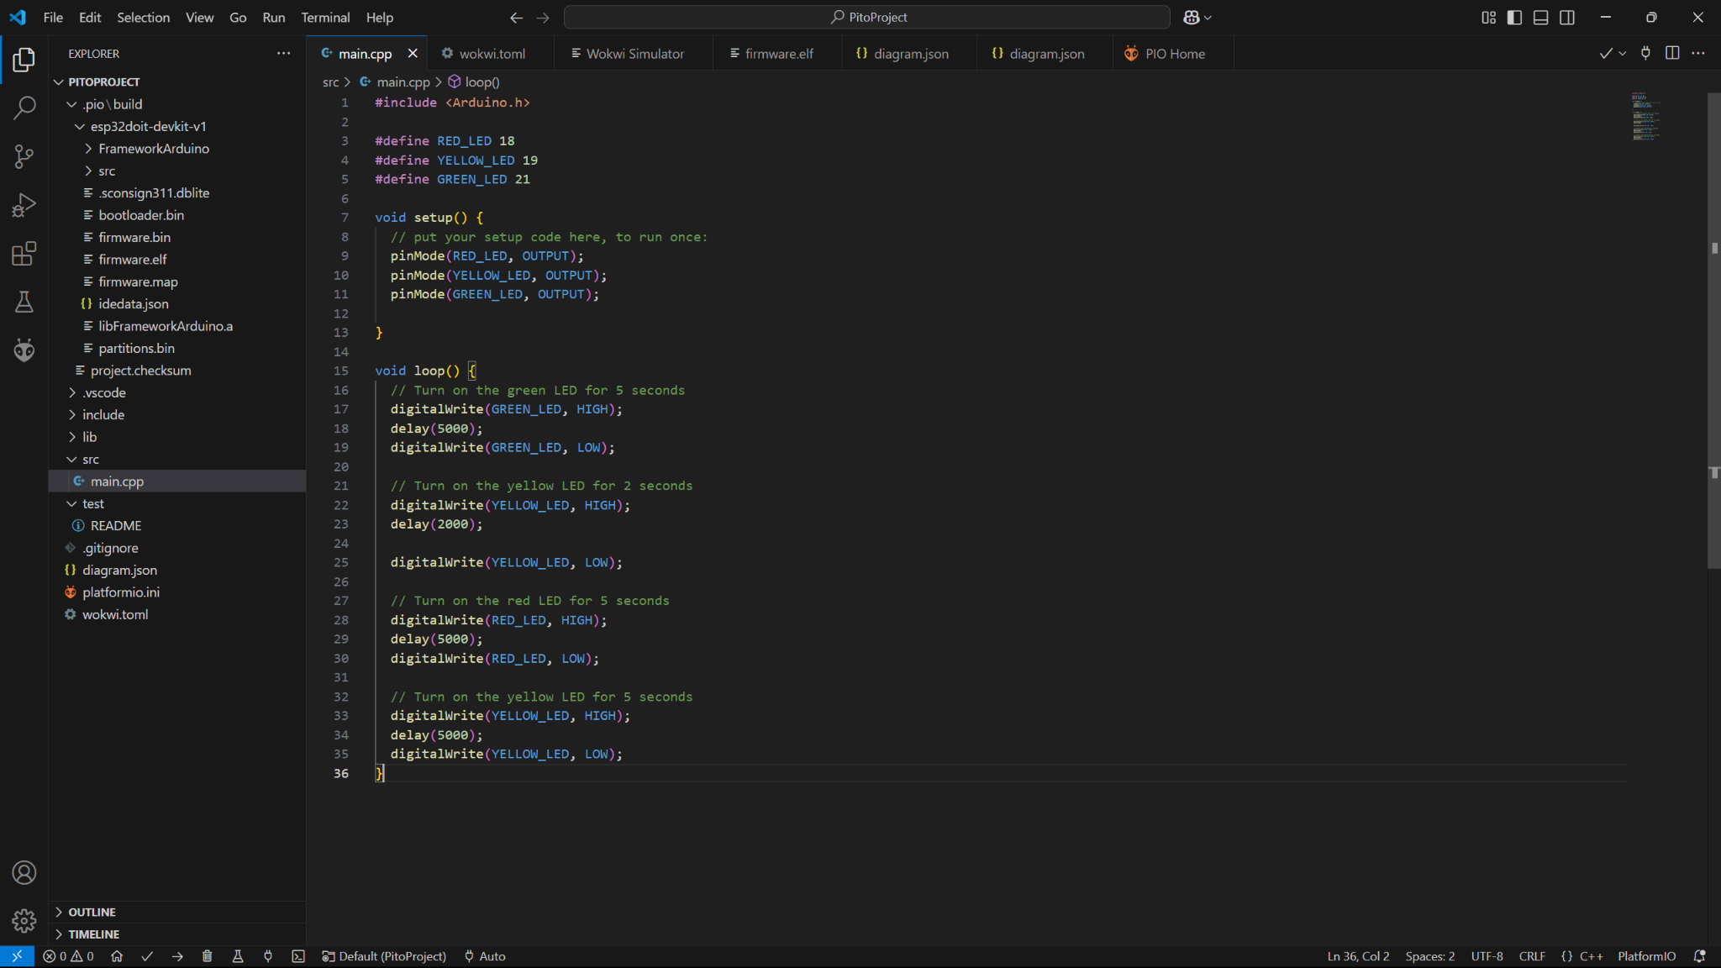

**3. Results and Discussion (Hasil dan Pembahasan)**

**3.1 Experimental Results (Hasil Eksperimen)**

**4. Appendix (Lampiran, jika diperlukan)**

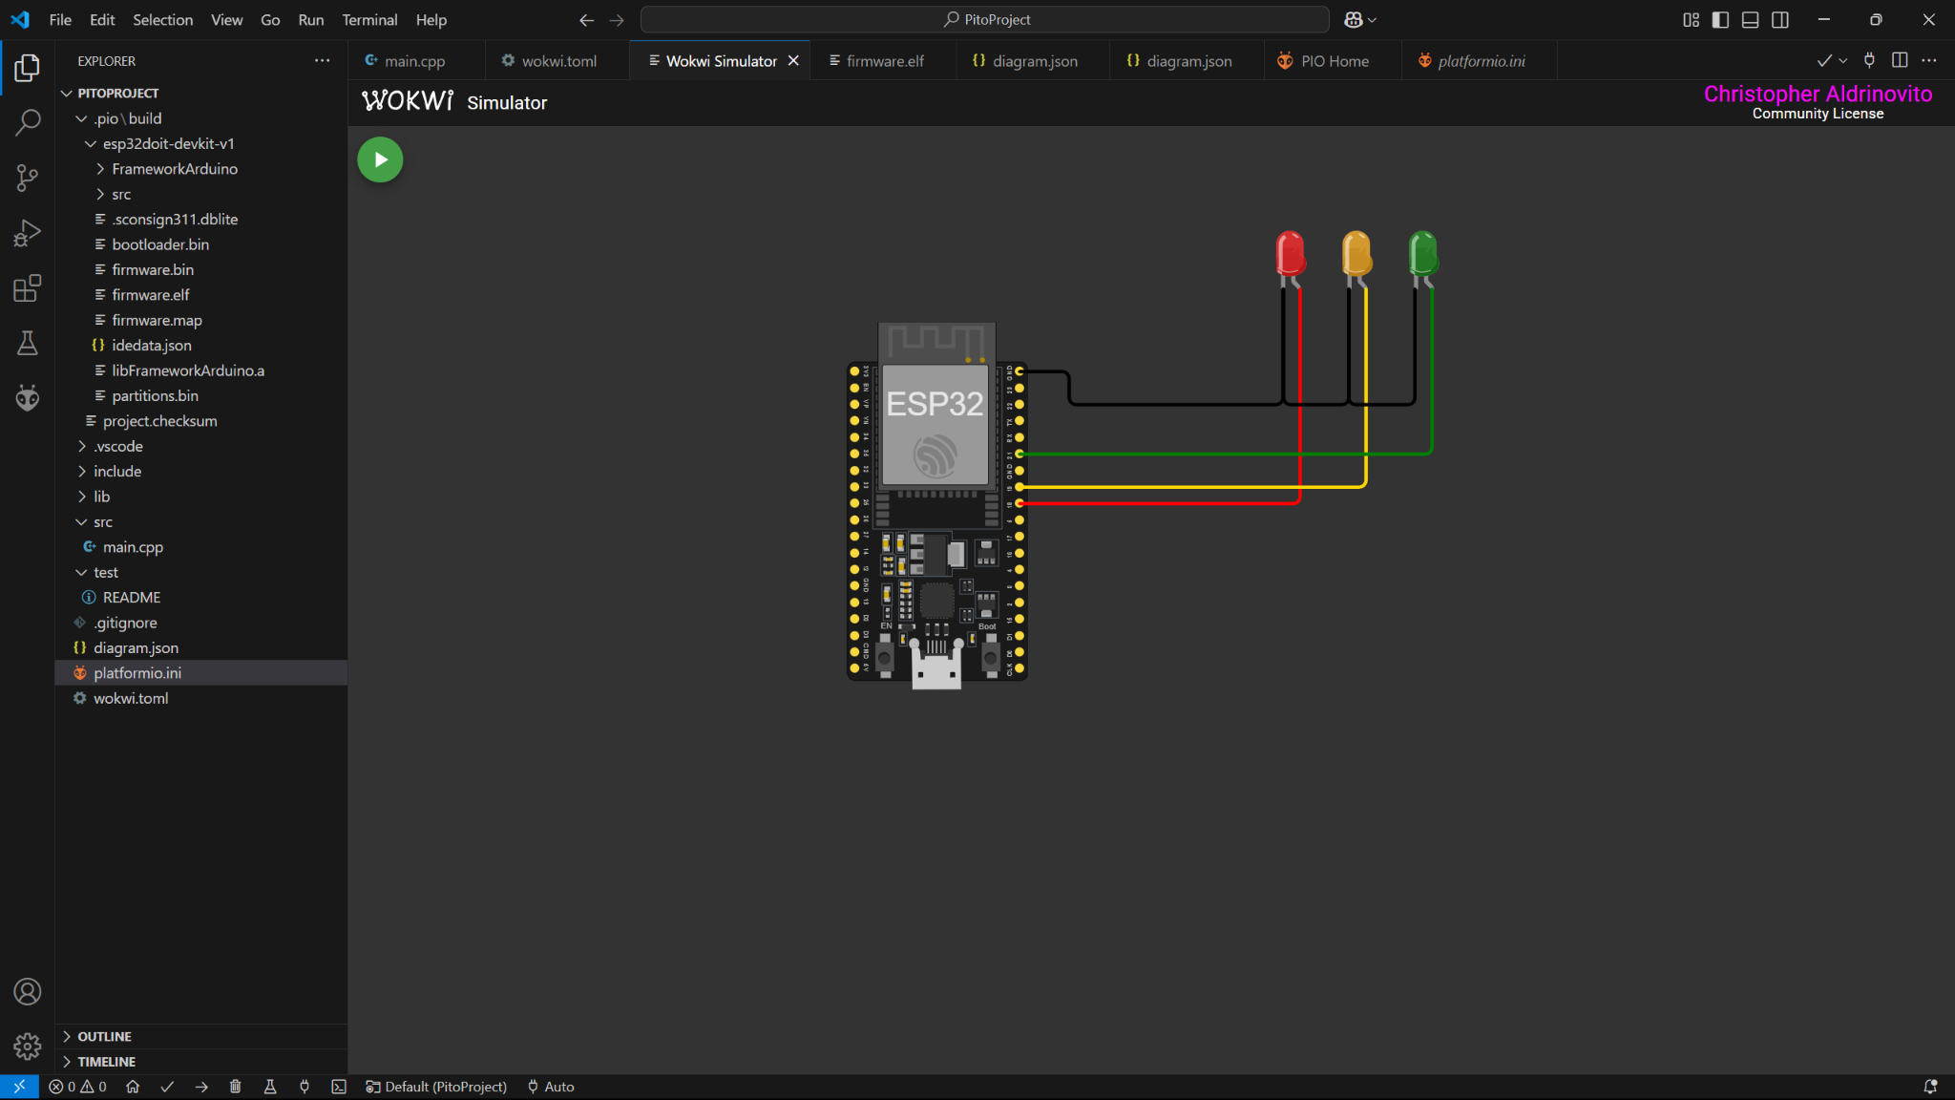

Lampu Menyala sesuai code yang kita buat.

Code traffic

#include <Arduino.h>

#define RED_LED 18

#define YELLOW_LED 19

#define GREEN_LED 21

void setup() {

// put your setup code here, to run once:

pinMode(RED_LED, OUTPUT);

pinMode(YELLOW_LED, OUTPUT);

pinMode(GREEN_LED, OUTPUT);

}

void loop() {

// Turn on the green LED for 5 seconds

digitalWrite(GREEN_LED, HIGH);

delay(5000);

digitalWrite(GREEN_LED, LOW);

// Turn on the yellow LED for 2 seconds

digitalWrite(YELLOW_LED, HIGH);

delay(2000);

digitalWrite(YELLOW_LED, LOW);

// Turn on the red LED for 5 seconds

digitalWrite(RED_LED, HIGH);

delay(5000);

digitalWrite(RED_LED, LOW);

// Turn on the yellow LED for 5 seconds

digitalWrite(YELLOW_LED, HIGH);

delay(5000);

digitalWrite(YELLOW_LED, LOW);

}

Diagram.json

{

"version": 1,

"author": "Christopher Aldrinovito",

"editor": "wokwi",

"parts": [

{ "type": "board-esp32-devkit-c-v4", "id": "esp", "top": 0, "left": -4.76, "attrs": {} },

{

"type": "wokwi-led",

"id": "led1",

"top": -61.2,

"left": 311,

"attrs": { "color": "green" }

},

{

"type": "wokwi-led",

"id": "led2",

"top": -61.2,

"left": 272.6,

"attrs": { "color": "orange" }

},

{

"type": "wokwi-led",

"id": "led3",

"top": -61.2,

"left": 234.2,

"attrs": { "color": "red" }

}

],

"connections": [

[ "esp:TX", "$serialMonitor:RX", "", [] ],

[ "esp:RX", "$serialMonitor:TX", "", [] ],

[ "led3:A", "esp:18", "red", [ "v0" ] ],

[ "led2:A", "esp:19", "gold", [ "v0" ] ],

[ "led1:A", "esp:21", "green", [ "v0" ] ],

[ "led1:C", "led2:C", "black", [ "v67.2", "h-38" ] ],

[ "led2:C", "led3:C", "black", [ "v67.2", "h-38", "v-76.8" ] ],

[ "led3:C", "esp:GND.2", "black", [ "v67.2", "h-124.4", "v-28.8" ] ]

],

"dependencies": {}

}